|  |  |
| --- | --- |
| **Solution for Traveling Salesman Problem and analysis of error and time complexity** |   **University of Padova**  **Department of Mathematics**  **“Tullio Levi-Civita”** |
| **Syed Riaz Raza[1]  Rana Mandal[2] Muhammad Tabish[3]**  * **Homework 2 Report for “**[**Advanced Algorithms**](https://elearning.unipd.it/math/mod/assign/view.php?id=44431)**”** |

|  |  |
| --- | --- |
| **Keywords**  Advance Algorithms,  Nearest Neighbor,  Random Insertion  2Approximation, Constructive heuristics,  Complexity,  UNIPD,  Padova, Italy | **Abstract:**  **I**n this report we will compare the execution times and the quality of the solutions that can be obtained with different approximation algorithms.   1. **Nearest Neighbor Algorithm** (Constructive Heuristics**).** 2. **Random Insertion Algorithm** (Constructive Heuristics). 3. **2-approximate algorithm based on MST.**   The report summarizes the result in following way:   * Visualize the result using matplotlib one-by-one * Comparing the result of one algorithm with other one and vice versa * Conclude the result |

Table of Contents

1. Introduction: 3

a. Definition of TSP (Travelling Salesman Problem): 3

b. Some notations for TSP are given: 3

2. Project Structure: 3

A. Implementation: 3

B. Output Result: 4

C. Asymptotic Notation & Visualization: 4

3. TSP Solution 5

A. Nearest Neighbor: 5

a. Working: 5

b. Pseudocode: 5

c. Complexity: 6

d. Visualization 6

B. Random Insertion: 7

a. Pseudo Code: 7

b. Complexity 7

c. Visualization: 7

C. Two Approximation Algorithm: 8

a. Why 2 Approximation: 8

b. Prims Algorithm in brief: 8

c. Approximation factor: 9

d. Time complexities: 9

e. Visualization: 9

4. Question 1: 10

5. Question 2 11

6. Originality 13

7. Conclusion 13

8. Dataset Result: 14

A. Nearest Neighbor 14

B. Random Insertion: 15

C. 2 Approximation: 16

# Introduction:

### Definition of TSP (Travelling Salesman Problem):

The traveling salesman problem (TSP) is an algorithmic problem tasked with finding the shortest route between a set of points and locations that must be visited. In the problem statement, the points are the cities a salesperson might visit. The salesman’s goal is to keep both the travel costs and the distance traveled as low as possible.

### Some notations for TSP are given:

Input: undirected, complete and weighted graph G = (V, E) with weights c: V × V 7→ N

Output: shortest Hamiltonian cycle in G

# Project Structure:

## Implementation:

We implemented most of our algorithms using adjacency matrix as an object in TSP class. (adjMatrix)

Other than the core data structures (for each algorithm), some functions are the same in all project files like:

**Core Program Units:**

* class TSP (diff for each algo)
* class Prim: (diff for each algo)
* class Two Approximation: (diff for each algo)
* class Nearest Neighbor: (diff for each algo)
* class Random Insertion: (diff for each algo)

**Additional functions (Same for all algo implementations):**

* funct load_all_dataset (Load All Dataset)
* funct populate_each_Graph_from_Dataset (Populate dataset to given Graph class)
* funct execute_each_graph_in_dataset (Compute and execute each dataset with their complexity and export the result into csv)
* funct main (main calling function)

## Output Result**:**

The result created as output for each algorithm implementation is in .csv format, and all the project files implementing the algorithm are using the same format to export the data.

* Dataset Name
* Number of Nodes
* Weight (weight for each dataset)
* nano seconds time (ns time took to compute TSP for each graph)
* seconds time (s time took to compute TSP for each graph)
* exe times (num_time calculation done on each graph)

## Asymptotic Notation & Visualization:

To compute Error Ratio and Asymptotic complexity for each algorithm the following parameters were created for each graph in dataset (for each algorithm implementation):

**Note:** Our work here to solve an intractable problem and to compare the execution times and Computing Ration and Constant:

**Note:** n here is the number of a graph in a dataset

* ratios= TSP [estimated_time][n+1] **/** TSP [estimated_time][n]
* constant= TSP [estimated_time] [n] / TSP [num_nodes][n]
* reference = avg(constant)* TSP [n][num_nodes])

We have created a separate file system which import the computational results of algorithm as mentioned in above paragraph and visualize the result of algorithms in following category

* Computational complexity of the algorithm
* Theoretical(C) computational complexity of the algorithm (reference variable)

And relative error calculated as:

# TSP Solution

## Nearest Neighbor:

Nearest Neighbor Algorithm was one of the first algorithms used to determine a solution to the traveling salesman problem. In it, the salesman starts in a random city and repeatedly visits the nearest city until all have been visited. It quickly yields a short tour, but usually not the optimal one.

The nearest neighbor algorithm is easy to implement and executes quickly, but it can sometimes miss shorter routes which are easily noticed with human insight, due to its “greedy” nature. As a general guide, if the last few stages of the tour are comparable in length to the first stages, then the tour is reasonable; if they are much greater, then it is likely that there are much better tours.

Another check is to use an algorithm such as the lower bound algorithm to estimate if this tour is good enough. In the worst case, the algorithm results in a tour that is much longer than the optimal tour.

### Working:

* 1. Initialize all vertices as unvisited.
  2. Select an arbitrary vertex, set it as the current vertex **u**. Mark **u** as visited.
  3. Find out the shortest edge connecting the current vertex **u** and an unvisited vertex **v**.
  4. Set **v** as the current vertex **u**. Mark **v** as visited.
  5. If all the vertices in the domain are visited, then terminate. Else, go to step 3

### Pseudocode:

1. **Initialization:**

Take the first node

            * Add it to finalPath

            * Add its index to visited

        * Delete the node from the starting set

1. **Selection:**  Search for nodes

        * Let (V1, ..., Vk) be the current path:

            * Take the vertex Vk + 1 not present & with minimum distance from Vk

1. **Insertion:** * Insert Vk + 1 after Vk

            * Update the weight value

            * Delete the node Vk + 1 from the starting set

1. repeat from (2) until all vertices are inserted in the path.

### Complexity:

The time complexity of the nearest neighbor algorithm is O(n^2). The number of computations required will not grow faster than n^2.

### Visualization

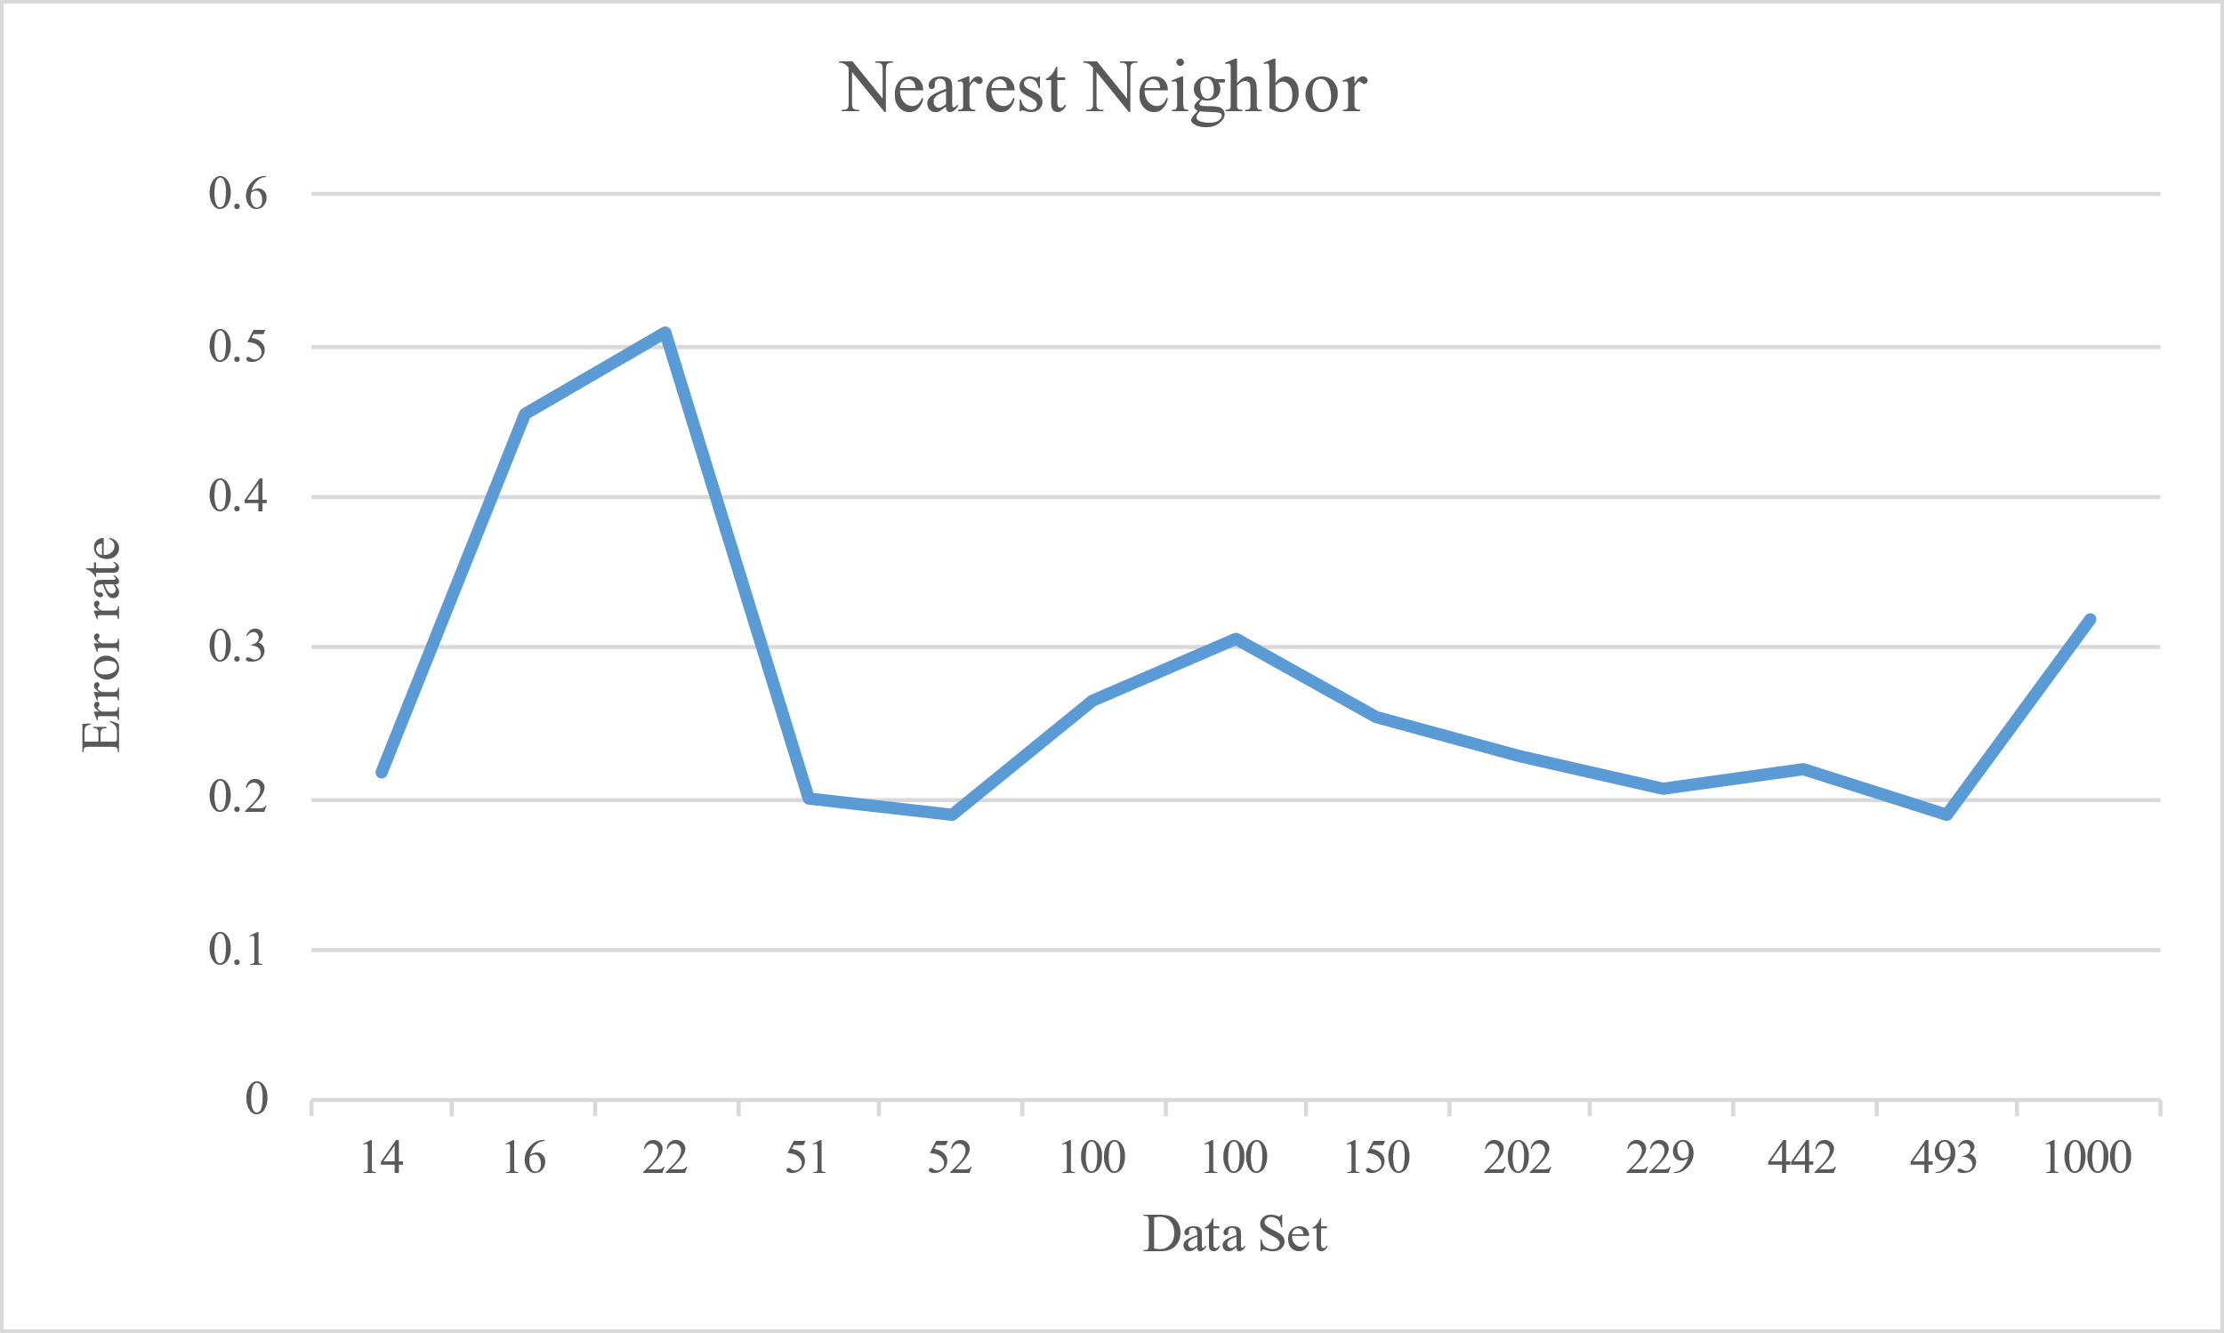

**Figure 1:** Nearest Neighbor error rate with for each dataset.

The graph just illustrated (fig. 1) shows that Error rate for Nearest Neighbor. As we can see the minimum error rate is near 0.2 and the maximum error rate is more than 0.5. And from the above shown graph we can see the average error rate is 0.2743154.

## Random Insertion:

Random Insertion also begins with two cities. It then randomly selects a city not already in the tour and inserts it between two cities in the tour. Rinse, wash, repeat.

### Pseudo Code:

1. Initialization: start from the single-node path 0. Find the vertex j that minimize w(0, j) and build the partial circuit (0, j);

2. Selection: randomly select a vertex k not in the circuit.

3. Insertion: find the edge {i, j} of the partial circuit that minimize w(i, k) + w(k, j) − w(i, j) and insert k between i and j;

4. repeat from (2) until all vertices are inserted in the path.

### Complexity

Time complexity: O(n^2) Visualization:

### Visualization:

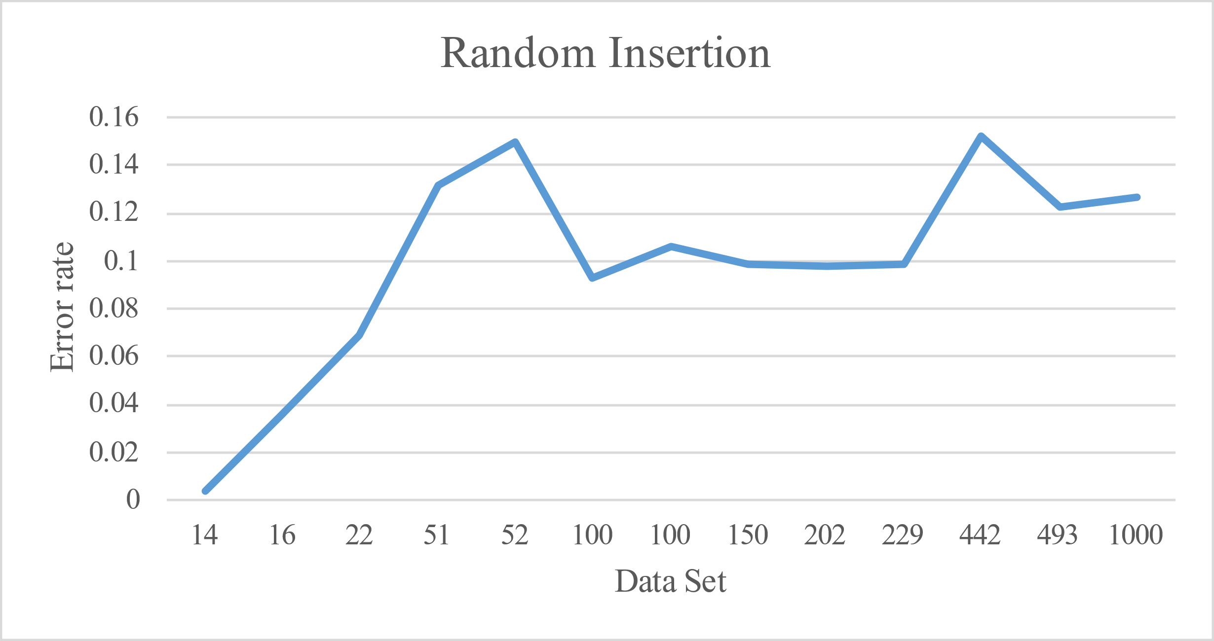

**Figure 2:** Random Insertion error rate for each data set.

The graphs just illustrated (fig. 2,) show that error rate starting from 0(minimum) to near 0.16(maximum). and as we can see that the minimum error rate is 0 so we can say that is very efficient. And the average error rate is 0.099008.

## Two Approximation Algorithm:

When the cost function satisfies the triangle inequality, we may design an approximate algorithm for the Travelling Salesman Problem that returns a tour whose cost is never more than twice the cost of an optimal tour. The idea is to use **Minimum Spanning Tree (MST)**.

1. Let 0 be the starting and ending point for salesman.

2. Construct Minimum Spanning Tree from with 0 as root using Prim’s Algorithm.

3. List vertices visited in preorder walk/Depth First Search of the constructed MST and add source node at the end.

### Why 2 Approximation:

1. The cost of best possible Travelling Salesman tour is never less than the cost of MST. (The definition of MST says it is a minimum cost tree that connects all vertices).
2. The total cost of full walk is at most twice the cost of MST (Every edge of MST is visited at-most twice)
3. The output of the above algorithm is less than the cost of full walk.

### Prims Algorithm in brief:

Creating a set mstSet that keeps track of vertices already included in MST.

Assigning a key value to all vertices in the input graph. Initialize all key values as INFINITE. Assign key value as 0 for the first vertex so that it is picked first.

[The Loop] While mstSet doesn’t include all vertices

* Pick a vertex u which is not there in mstSet and has minimum key value. (minimum_key())
* Include u to mstSet.
* Update key value of all adjacent vertices of u. To update the key values, iterate through all adjacent vertices. For every adjacent vertex v, if weight of edge u-v is less than the previous key value of v, update the key value as weight of u-v.

### Approximation factor:

If the triangular inequality is respected: I Nearest Neighbor, Random Insertion and Farthest Insertion give a log(n)-approximation I

Closest Insertion and Cheapest Insertion find a 2-approssimation

### Time complexities:

The time complexity for obtaining MST from the given graph is O(V^2) where V is the number of nodes. The worst case space complexity for the same is O(V^2), as we are constructing a vector<vector<int>> data structure to store the final MST.

### Visualization:

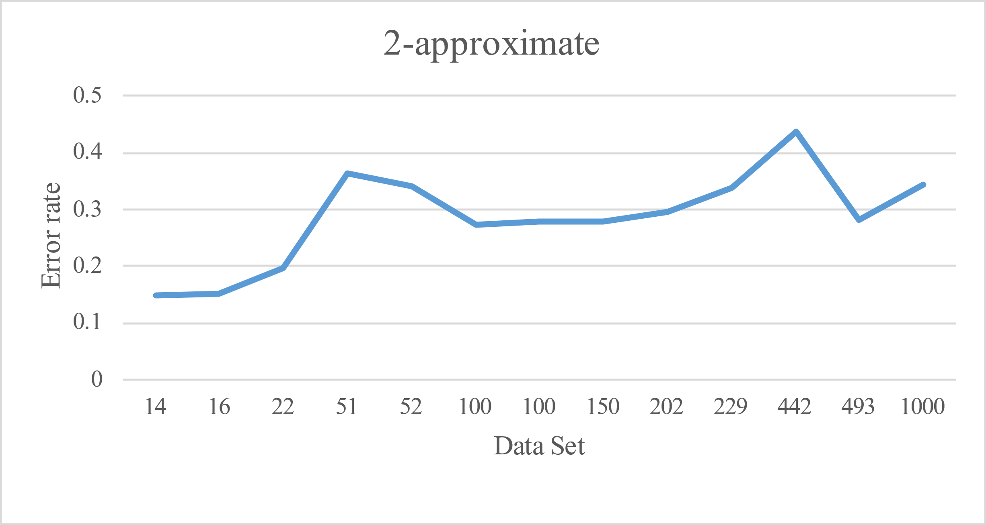

**Figure 3:** 2 Approximation algorithm error rate for each data set.

The graphs just illustrated (fig. 3) that the Error Rate is minimum 0.15 and maximum 0.4. And the average error rate is 0.286992.

# Question 1:

Run the three algorithms (the two constructive heuristics and 2-approximate) on the 13 graphs of the dataset. Show your results in a table like the one below. The rows in the table correspond to the problem instances. The columns show, for each algorithm, the weight of the approximate solution, the execution time and the relative error calculated as:

|  |  |  |  |  |  |  |  |  |  |
| --- | --- | --- | --- | --- | --- | --- | --- | --- | --- |
| **Instance** | **Nearest Neighbor** |  |  | **Random insertion** |  |  | **2 Approximation** |  |  |
| **Solution** | **Time(NS)** | **Error** | **Solution** | **Time(NS)** | **Error** | **Solution** | **Time(NS)** | **Error** |
| burma14 | 4048 | 0.000305 | 0.2181 | 3336 | 0.000277 | 0.0039 | 3814 | 0.0005762 | 0.1477 |
| ulysses16 | 9988 | 0.000357 | 0.4561 | 7108 | 0.0004177 | 0.0363 | 7903 | 0.000511 | 0.1522 |
| ulysses22 | 10586 | 0.000576 | 0.5094 | 7499 | 0.0005553 | 0.0692 | 8401 | 0.0009334 | 0.1979 |
| eil51 | 511 | 0.002442 | 0.1995 | 482 | 0.0022051 | 0.1314 | 581 | 0.004621 | 0.3638 |
| berlin52 | 8980 | 0.002526 | 0.1906 | 8675 | 0.0023586 | 0.1502 | 10114 | 0.0042765 | 0.341 |
| kroD100 | 26947 | 0.008881 | 0.2654 | 23280 | 0.010828 | 0.0932 | 27112 | 0.0170665 | 0.2732 |
| kroA100 | 27807 | 0.012 | 0.3065 | 23534 | 0.0082532 | 0.1058 | 27210 | 0.0136536 | 0.2785 |
| ch150 | 8191 | 0.019588 | 0.2547 | 7173 | 0.0174658 | 0.0988 | 8347 | 0.0391449 | 0.2786 |
| gr202 | 49336 | 0.039137 | 0.2284 | 44094 | 0.0313031 | 0.0979 | 51990 | 0.0900801 | 0.2945 |
| gr229 | 162430 | 0.055076 | 0.2067 | 147855 | 0.0404945 | 0.0984 | 180152 | 0.0919448 | 0.3384 |
| pcb442 | 61979 | 0.232967 | 0.2205 | 58511 | 0.2341759 | 0.1522 | 73030 | 0.3178809 | 0.4382 |
| d493 | 41660 | 0.287488 | 0.1902 | 39299 | 0.2342507 | 0.1227 | 44892 | 0.430566 | 0.2825 |
| dsj1000 | 24630960 | 1.121442 | 0.32 | 21032671 | 0.9385765 | 0.1271 | 25086767 | 1.5908348 | 0.3444 |

# Question 2

Comment on the results you have obtained: how do the algorithms behave with respect to the various instances? There is an algorithm that is always better than the others? Which of the three algorithms you have implemented is more efficient?

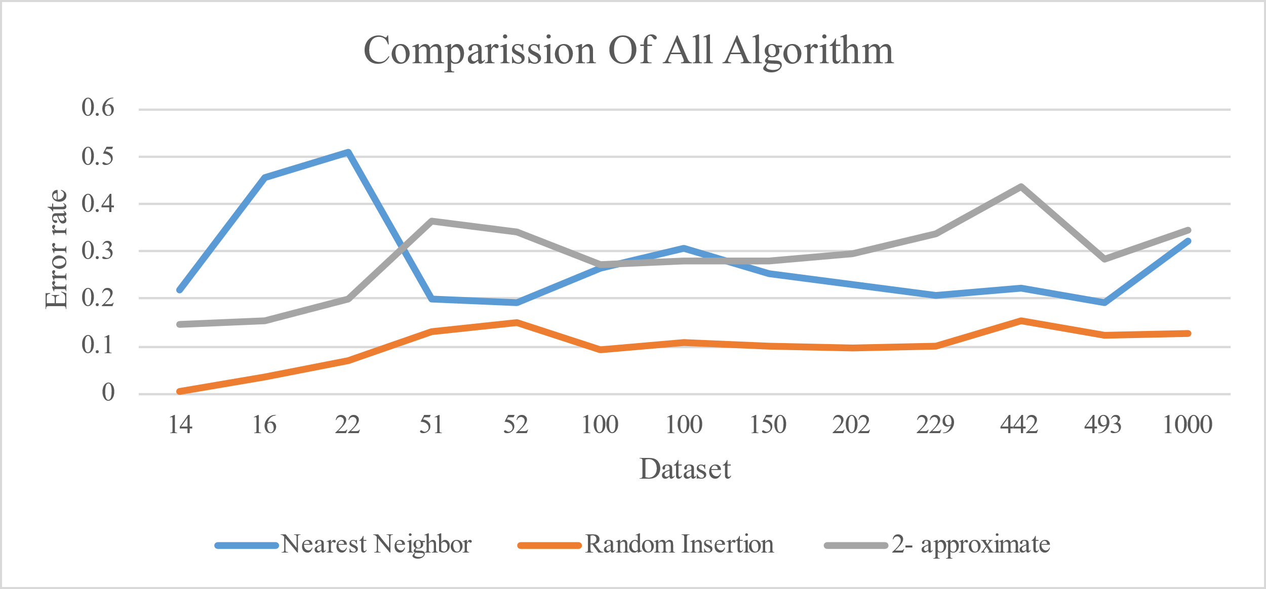

**Figure 4:** Comparison of the error rate between Nearest Neighbor, Random Insertion and 2-Approximation with execution of each graph.

The graphs just illustrated (fig. 4) show three comparisons between the Nearest Neighbor, Random Insertion and 2-Approximation algorithm on a linear scale

In this case it is possible to clearly see that Random Insertion algorithm turns out to be more efficient than Nearest Neighbor algorithm and 2-Approximation Algorithm. From this therefore we can conclude that the Random Insertion algorithm always tends to do better than the others.

**Figure 5:** Comparison of three algorithm based on TSP solution with respect to number of nodes and time(ns).

The illustration (fig. 5) shows three comparisons between the Nearest Neighbor, Random Insertion and 2-Approximation algorithm on the basis on TSP solution. As shown above we can state that the time complexity (w.r.t increasing number of nodes) random insertion is more efficient than others two algorithms (Nearest Neighbor & 2 approximation).

As it can be shown from (fig:4) that the efficiency of the random algorithm is more than the nearest neighbor and 2 Approximation algorithm, the error rate is less in the random insertion as compared to the Nearest neighbor and 2 approximations.

# Originality

* In this assignment we have optimized naive Random Insertion part where we must maintain partial circle with min cost**. We have used the working application of k-center algorithm (Facility location problems with outliers)** which uses 3 variables (partial_circle, adjMatrix, nodes).
* All algorithms including Nearest Neighbor, Random Insertion and 2 Approximation used 2D adjacency matrix.
* We created our own custom implementation of Priority Queue.
* We created one-for-all system to extract and execute dataset for different TSP solution. The TSP class can be used to execute other heuristic algorithm (with little to no changes).

# Conclusion

The problems we faced during the work of our assignment:

* We ran into problem of Maintaining the partial circle in the Random Insertion because we reused the prims algorithm from 1st assignment and the error rate was greater than 1.5 so we had to reduce the error rate and tried to optimize the prims for TSP.

To conclude, what we have turned out for the algorithms is in line with what we expected, in fact:

* **Nearest Neighbor** is the highest one in error rate amongst three algorithms and the second efficient in terms of average time with increasing number of nodes.
* **Random Insertion** can be ranked first in all terms, as it is the fast and efficient in terms of average time with increasing number of nodes and one with least error rate amongst three algorithms.
* **2 Approximation Algorithm** can be ranked in second place with respect to error rate touching line with Nearest Neighbor, and the worst in average time with increasing number of nodes. The result of 2-Approx is ambiguous because maybe we can also use another MST algorithm which is more optimized like Kruskal with Union-Find

Concluding did good on our side, although our use of the Python language, although relatively simple, it was too slow as compared to working in Java. With java we could have made a quite good interactive application, and we wouldn’t have face typo error or library errors.

# Dataset Result:

## Nearest Neighbor

|  |  |  |  |  |  |
| --- | --- | --- | --- | --- | --- |
| Dataset | # of Nodes | TSP result | Time (ns) | Time(s) | Execution Time |
| burma14 | 14 | 4048 | 291540.558 | 0.000292 | 2044 |
| ulysses16 | 16 | 9988 | 383723.651 | 0.000384 | 1019 |
| ulysses22 | 22 | 10586 | 642851.814 | 0.000643 | 1378 |
| eil51 | 51 | 511 | 2991694.84 | 0.002992 | 426 |
| berlin52 | 52 | 8980 | 3224192.07 | 0.003224 | 164 |
| kroD100 | 100 | 26947 | 9094924.32 | 0.009095 | 111 |
| kroA100 | 100 | 27807 | 12071702.7 | 0.012072 | 112 |
| ch150 | 150 | 8191 | 20490159.6 | 0.02049 | 52 |
| gr202 | 202 | 49336 | 39077350 | 0.039077 | 26 |
| gr229 | 229 | 162430 | 58460488.2 | 0.058461 | 17 |
| pcb442 | 442 | 61979 | 305381400 | 0.305381 | 4 |
| d493 | 493 | 41660 | 305032250 | 0.305032 | 2 |
| dsj1000 | 1000 | 24630960 | 1156798700 | 1.156799 | 1 |

## Random Insertion:

|  |  |  |  |  |  |
| --- | --- | --- | --- | --- | --- |
| **Dataset** | **# of Nodes** | **TSP result** | **Time (ns)** | **Time(s)** | **Execution Time** |
| **burma14** | 14 | 3455 | 304361.3718 | 0.000304 | 1662 |
| **ulysses16** | 16 | 7495 | 330368 | 0.00033 | 1100 |
| **ulysses22** | 22 | 7559 | 572849.5787 | 0.000573 | 1424 |
| **eil51** | 51 | 469 | 2244229.106 | 0.002244 | 481 |
| **berlin52** | 52 | 8207 | 4099014.872 | 0.004099 | 195 |
| **kroD100** | 100 | 24439 | 8365454.478 | 0.008366 | 134 |
| **kroA100** | 100 | 22537 | 8375222.047 | 0.008375 | 127 |
| **ch150** | 150 | 7259 | 19744541.51 | 0.019745 | 53 |
| **gr202** | 202 | 45008 | 34844210 | 0.034844 | 30 |
| **gr229** | 229 | 146713 | 60194130.43 | 0.060194 | 23 |
| **pcb442** | 442 | 57567 | 156046850 | 0.156047 | 4 |
| **d493** | 493 | 38535 | 208495500 | 0.208496 | 4 |
| **dsj1000** | 1000 | 20975443 | 877430200 | 0.87743 | 1 |

## 2 Approximation:

|  |  |  |  |  |  |
| --- | --- | --- | --- | --- | --- |
| Dataset | # Of Nodes | TSP result | Time (ns) | Time (s) | Execution Time |
| burma14 | 14 | 3814 | 480670.989 | 0.000481 | 1820 |
| ulysses16 | 16 | 7903 | 580390.49 | 0.00058 | 1041 |
| ulysses22 | 22 | 8401 | 908055.417 | 0.000908 | 480 |
| eil51 | 51 | 581 | 5293788.44 | 0.005294 | 199 |
| berlin52 | 52 | 10114 | 4389928.46 | 0.00439 | 253 |
| kroD100 | 100 | 27112 | 17289541.5 | 0.01729 | 53 |
| kroA100 | 100 | 27210 | 13710138.8 | 0.01371 | 80 |
| ch150 | 150 | 8347 | 39826250 | 0.039826 | 26 |
| gr202 | 202 | 51990 | 96071507.1 | 0.096072 | 14 |
| gr229 | 229 | 180152 | 91616663.6 | 0.091617 | 11 |
| pcb442 | 442 | 73030 | 295390867 | 0.295391 | 3 |
| d493 | 493 | 44892 | 435337900 | 0.435338 | 2 |
| dsj1000 | 1000 | 25086767 | 1647512900 | 1.647513 | 1 |

**EOF**

1. **Syed Riaz Raza; E-mail:** [syedriaz.raza@studenti.unipd.it](mailto:syedriaz.raza@studenti.unipd.it); **Portfolio**: [riazraza.me](https://riazraza.me/)
2. **Rana Mandal; E-mail:** [rana.mandal@studenti.unipd.it](mailto:rana.mandal@studenti.unipd.it);
3. **Muhammad Tabish; E-mail:** [muhammad.tabish@studenti.unipd.it](mailto:muhammad.tabish@studenti.unipd.it);